Sending a Digital Application through ‘We Transfer’.



Early Intervention Centre Applications 2025/26

# Digital Application Checklist

## The following documents need to be scanned and included in your digital application:

* Completed and signed application form
* Proof of Address in the form of a utility bill
* Copy of the child’s evaluation report confirming their autism diagnosis.
* A written recommendation from a certified psychologist for an ASD-specific education in a special school.
* Copy of the child’s birth certificate.

## Additional Documentation (Optional)

* Speech and Language Report
* Occupational Therapy Report
* Other documentation from professionals that you may deem relevant

# Steps for Sending Files through We Transfer

* Scan and label your documentation. Documentation can be scanned all together as a single file or alternatively a folder can be sent through We Transfer containing individual relevant files. In both scenarios label the file/folder ‘Child_Name_Abacas_2025’ e.g. **Jane_Smith_Abacas_2025.**
* Go to the website <https://wetransfer.com/>
* Click **‘I agree’** to terms of service.
* Follow the below steps

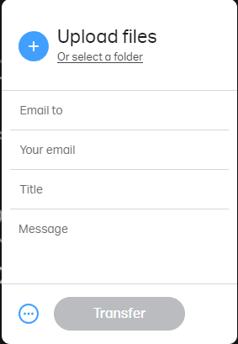

**Click on the + sign and add the file you want to send or click ‘select a folder’ to upload a folder.**

**Type in the email address:**

[**abacaskilbarrackapplications@gmail.com**](mailto:abacaskilbarrackapplications@gmail.com)

**Type in your own email**

**Type ‘Child First Name, Child Last Name**

**Application’ e.g. Jane Smith Application Write a short message if you like.**

**Then just hit ‘Transfer’.**

* **Enter your WeTransfer code.** Before sending your files, WeTransfer needs

to verify your email address. You will receive a **six-digit code** via email that you need to enter. This code is active for 60 minutes. If you don’t manage to input it in time, you can request a new code.

**You’ll receive two emails after sending your application through WeTransfer. The first email message includes a confirmation that your file transfer has been sent, and the second one is sent when the school downloads the submitted file.**